**4. PROPOSED METHOD**

**4.1 Simultaneous AC-DC Power Transmission:**

Depicts the basic scheme for simultaneous ac–dc power flow through a double circuit ac transmission line. The dc power is obtained through line commutated 12-pulse rectifier bridge used in conventional HVDC and injected to the neutral point of the zigzag connected secondary of sending end transformer and is reconverted to ac again by the conventional line commutated 12-pulse bridge inverter at the receiving end. The inverter bridge is again connected to the neutral of zig-zag connected winding of the receiving end transformer.

The double circuit ac transmission line carriers both three-phase ac and dc power. Each conductor of each line carries one third of the total dc current along with ac current. Resistance being equal in all the three phases of secondary winding of zig-zag transformer as well as the three conductors of the line, the dc current is equally divided among all the three phases.

**4.1.1 BLOCK DIAGRAM REPRESENTATION**:

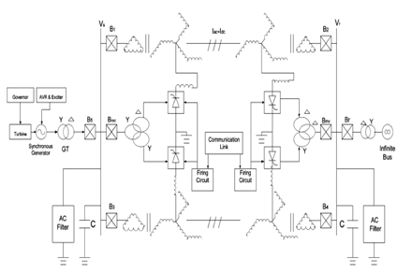

**Fig.4.1 Basic Scheme for Composite AC–DC Transmission.**

The three conductors of the second line provide return path for the dc current. Zig-zag connected winding is used at both ends to avoid saturation of transformer due to dc current. Two fluxes produced by the dc current $\left({I_{d}}/3\right)$ flowing through each of a winding in each limb of the core of a zig-zag transformer are equal in magnitude and opposite in direction. So the net dc flux at any instant of time becomes zero in each limb of the core.

Thus, the dc saturation of the core is avoided. A high value of reactor $X_{d}$ is used to reduce harmonics in dc current. In the absence of zero sequence and third harmonics or its multiple harmonic voltages, under normal operating conditions, the ac current flow through each transmission line will be restricted between the zigzag connected windings and the three conductors of the transmission line.

Even the presence of these components of voltages may only be able to produce negligible current through the ground due to high value of $X_{d}$. Assuming the usual constant current control of rectifier and constant extinction angle control of inverter [4], [8]–[10], the equivalent circuit of the scheme under normal steady-state operating condition is given in Fig. 2. The dotted lines in the figure show the path of ac return current only. The second transmission line carries the return dc current , and each conductor of the line carries $\left({I_{d}}/3\right)$ along with the ac current per phase. and are the maximum values of rectifier and inverter side dc voltages and are equal to ${3\sqrt{2}}/π$ times converter ac input line-to-line voltage. R, L, and C are the line parameters per phase of each line. , $R_{cr},R_{ci}$ are commutating resistances, and $α,γ$ are firing and extinction angles of rectifier and inverter, respectively. Neglecting the resistive drops in the line conductors and transformer windings due to dc current, expressions for ac voltage and current, and for active and reactive powers in terms of A, B, C, and D parameters of each line may be written as

$E_{δ}=AE_{R}+ BI_{R }$----------------1

$I_{δ}=CE_{R}+ DI_{R }$----------------2

$P_{δ}+jQ_{δ}=-E_{δ}{E_{R}^{*}}/{B^{*}}+D^{*}{E_{δ}^{2}}/{B^{*}}$--3

$P_{R}+jQ_{R}=E_{δ}^{*}{E_{R}}/{B^{*}}-{A^{*}E_{R}^{2}}/{B^{*}}$-------4

**4.2 Equivalent Circuit of Zig-Zag transformer**:

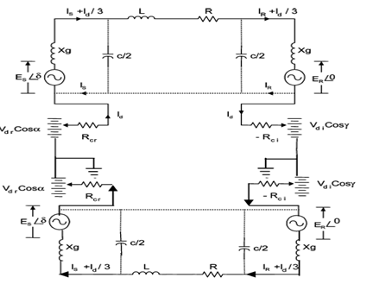

**Fig.4.2 Equivalent Circuit of Zig-Zag transformer**

Neglecting ac resistive drop in the line and transformer, the dc power $P_{dr}$ and $P_{di}$ of each rectifier and inverter may be expressed as

$P_{dr}=V_{dr}I_{d}$--------5

$P_{di}=V_{di}I_{d}$--------6

Reactive powers required by the converter are

$Q_{dr}=P_{dr}\tan{θ_{r}}$-----7

$Q_{di}=P_{di}\tan{θ_{i}}$------8

$\cos{θ_{r}}={\left[\cos{α}+\cos\left(α+μ_{r}\right)\right]}/2$-----9

$\cos{θ_{i}}={\left[\cos{γ}+\cos\left(γ+μ_{i}\right)\right]}/2$------10

$P_{δt}=P_{δ}+P_{dr} and P_{rt}=P_{R}+P_{di}$----11

$Q_{δt}=Q_{δ}+Q_{dr} and Q_{rt}=Q_{R}+Q_{di}$----12

Transmission loss for each line is

$P_{L}=\left(P_{S}+P_{dr}\right)-\left(P_{R}+P_{di}\right)$---------13

Ia being the rms ac current per conductor at any point of the line,

The total rms current per conductor becomes

$$I={\left[I_{a}^{2}+{\left({I_{d}}/3\right)}^{2}\right]}^{1/2}$$

Power loss for each line $=P_{L}≈3I^{2}R.$

The net current I in any conductor is offseted from zero. In case of a fault in the transmission system, gate signals to all the SCRs are blocked and that to the bypass SCRs are released to protect rectifier and inverter bridges. The current in any conductor is no more offseted. Circuit breakers (CBs) are then tripped at both ends to isolate the faulty line. CBs connected at the two ends of transmission line interrupt current at natural current zeroes, and no special dc CB is required. Now, allowing the net current through the conductor equal to its thermal limit $I_{th}$

$I_{th}={\left[I_{a}^{2}+\left({{I_{d}}/3}^{2}\right)\right]}^{1/2}$----------14

Let $V_{ph}$ be per-phase rms voltage of original ac line. Let also $V_{a}$ be the per-phase voltage of ac component of composite ac–dc line with dc voltage $V_{d}$ superimposed on it. As insulators remain unchanged, the peak voltage in both cases should be equal

$V_{max}=\sqrt{2}V_{ph}=V_{d}+\sqrt{2}V_{a}$------15

Electric field produced by any conductor possesses a dc component superimpose on it a sinusoidally varying ac component. However, the instantaneous electric field polarity changes its sign twice in a cycle if $\left({V_{d}}/{V_{a}}\right)<\sqrt{2}$ is insured. Therefore, higher creepage distance requirement for insulator discs used for HVDC lines are not required. Each conductor is to be insulated for , $V_{max}$ but the line-to-line voltage has no dc component and $V_{LLmax}=\sqrt{6}V_{a}$. Therefore, conductor-to-conductor separation distance of each line is determined only by rated ac voltage of the line. Allowing maximum permissible voltage offset such that the composite voltage wave just touches zero in each every cycle;

$V_{d}={V_{ph}}/{\sqrt{2} }and V_{a}={V_{ph}}/{2 }$------16

The total power transfer through the double circuit line before conversion is as follows:

$P_{total}^{'}≈3V_{ph}^{2}\sin{{δ_{1}}/X}$-------17

Where X is the transfer reactance per phase of the double circuit line, $δ_{1}$ and is the power angle between the voltages at the two ends. To keep sufficient stability margin, $δ_{1}$ is generally kept low for long lines and seldom exceeds 30 . With the increasing length of line, the load ability of the line is decreased [4]. An approximate value of $δ_{1}$ may be computed from the loadability curve by knowing the values of surge impedance loading (SIL) and transfer reactance X of the line

$P_{total}^{'}=2.M.SIL$-------18

Where M is the multiplying factor, and its magnitude decreases with the length of line. The value of M can be obtained from the load ability curve . The total power transfer through the composite line

$P_{total}=P_{ac}+P_{dc}=3V_{a}^{2}\sin{{δ_{2}}/{X }+ 2V_{d}I_{d}}$-----19

The power angle $δ_{2}$ between the ac voltages at the two ends of the composite line may be increased to a high value due to fast controllability of dc component of power. For a constant value of total power, $P_{ac}$ may be modulated by fast control of the current controller of dc power converters. Approximate value of ac current per phase per circuit of the double circuit line may be computed as

$I_{a}=V{\left(\sin{δ/2}\right)}/X$-----20

The rectifier dc current order is adjusted online as

$I_{d}=V3\sqrt{I_{th}^{*2}-I_{a}^{*2}}$---------21

Preliminary qualitative analysis suggests that commonly used techniques in HVDC/AC system may be adopted for the purpose of the design of protective scheme, filter, and instrumentation network to be used with the composite line for simultaneous ac–dc power flow.

In case of a fault in the transmission system, gate signals to all the SCRs are blocked and that to the bypass SCRs are released to protect rectifier and inverter bridges. CBs are then tripped at both ends to isolate the complete system.

A surge diverter connected between the zig-zag neutral and the ground protects the converter bridge against any over voltage.

**4.3 Description of the system model**

A synchronous machine is feeding power to infinite bus via a double circuit, three-phase, 400-KV, 50-Hz, 450-Km ac transmission line. The 2750-MVA (5 * 550), 24.0-KV synchronous machine is dynamically modelled, a field coil on d-axis and a damper coil on q-axis, by Park’s equations with the frame of reference based in rotor [4]. It is equipped with an IEEE type AC 4A excitation system of which block diagram is shown in Fig. 3. Transmission lines are represented as the Bergeron model. It is based on a distributed LC parameter travelling wave line model, with lumped resistance. It represents the L and C elements of a PI section in a distributed manner (i.e., it does not use lumped parameters).

It is roughly equivalent to using an infinite number of PI sections, except that the resistance is lumped (1/2 in the middle of the line, 1/4 at each end). Like PI sections, the Bergeron model accurately represents the fundamental frequency only. It also represents impedances at other frequencies, except that the losses do

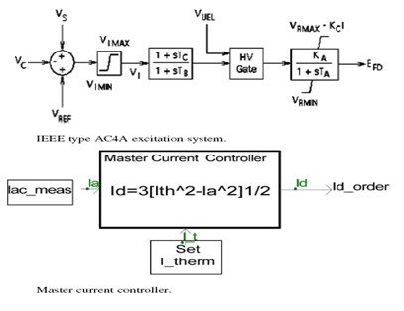

**Fig.4.3 Master Control**